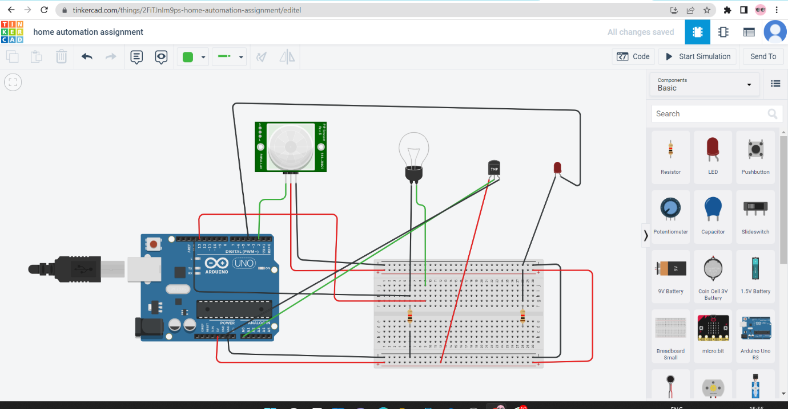

CODE:

int pirsensor=0;

int tempsensor=0;

void setup()

{

pinMode(13,OUTPUT);

pinMode(2,INPUT);

pinMode(4,OUTPUT);

pinMode(A0,INPUT);

Serial.begin(9600);

}

void loop()

{

pirsensor=digitalRead(2);

if (pirsensor==HIGH)

{

digitalWrite(13,HIGH);

delay(100);

}

else

{

digitalWrite(13,LOW);

delay(100);

}

tempsensor=analogRead(A0);

Serial.print("tempsensor=");

Serial.println(tempsensor);

if(tempsensor > 100)

{

digitalWrite(4,HIGH);

delay(100);

}

else

{

digitalWrite(4,LOW);

delay(100);

}

}